Python Course:

Day 2

BMI CALCULATOR

Life in Weeks

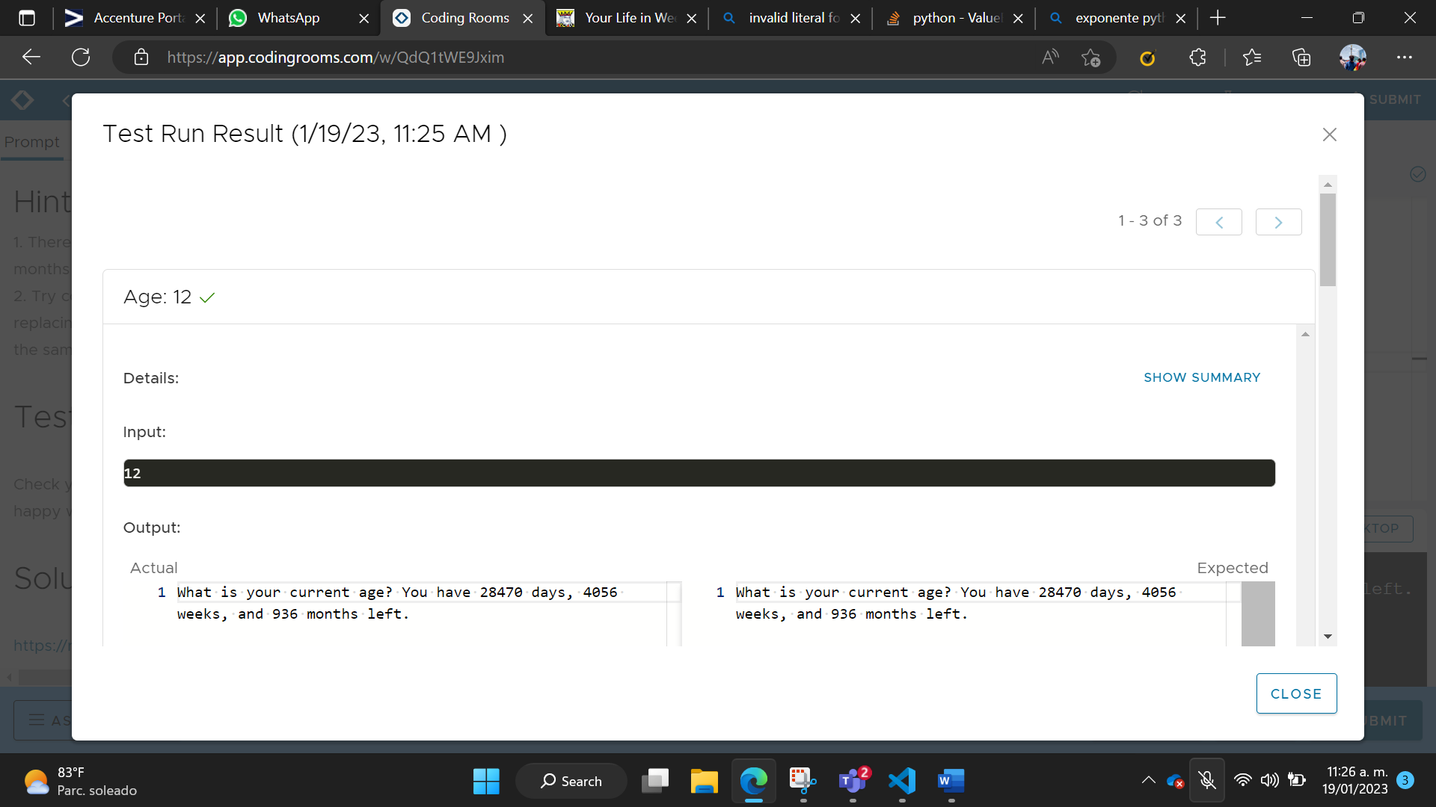

Life in Weeks Modificado

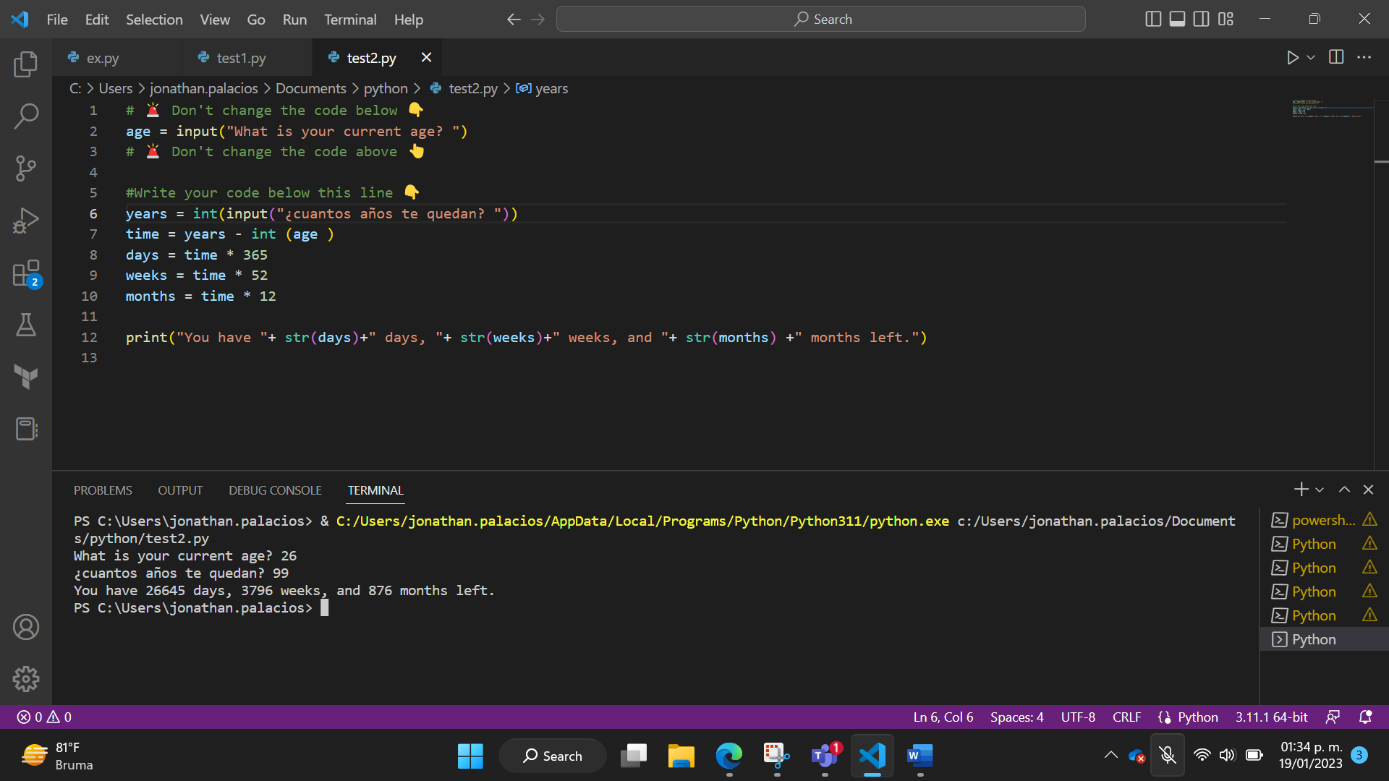

Odd or Even

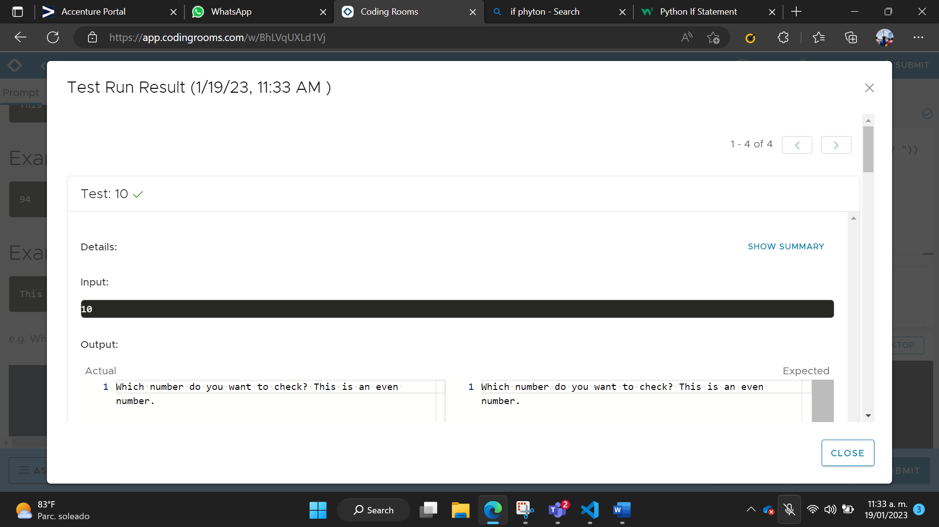

BMI 2.0

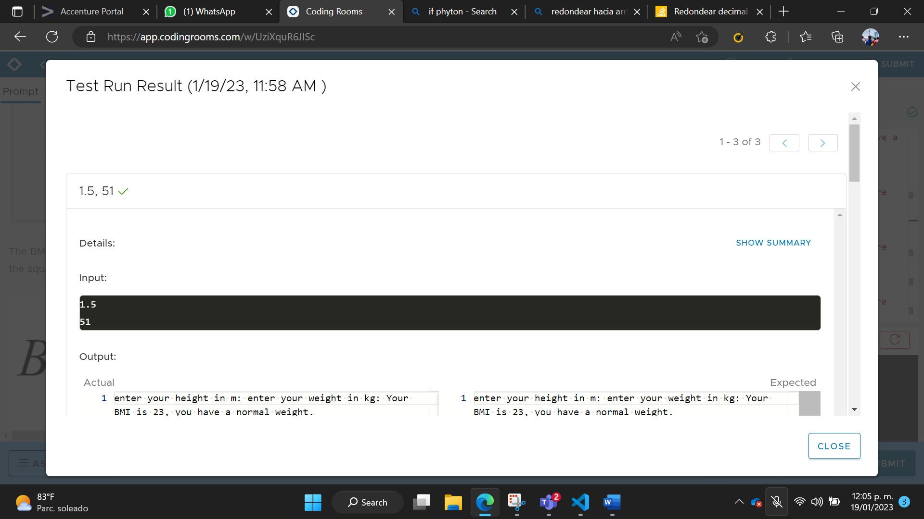

Leap Year

